 |  | 1509 West Orange Blossom Trail, Apopka, FL 32712 Phone: (407) 814-0436 Fax: (407) 814-0818
History Questionnaire
Name: |  |  | Date:
Contact Telephone Number: | E-mail Address:
Home Address:

Emergency Contact and Phone Number:

Date of Injury or symptoms:  ____/_____/____  mm dd yy | Description of injury or symptoms:
Date of Surgery:  ____/____/____  mm dd yy | Have you had this pain or problem before?  YES NO | Is your pain on the surface or deep?  Deep Surface
Medications: (include all medications)

Medical History
Allergies | O Yes O No | Depression | O Yes O No
Anemia | O Yes O No | Diabetes | O Yes O No
Anxiety | O Yes O No | Dizzy Spells | O Yes O No
Arthritis | O Yes O No | Emphysema/Bronchitis | O Yes O No
Asthma | O Yes O No | Fractures | O Yes O No
Cancer | O Yes O No | Gallbladder Problems | O Yes O No
Cardiac Conditions | O Yes O No | Hepatitis | O Yes O No
Cardiac Pacemaker | O Yes O No | High Blood Pressure | O Yes O No
Chemical Dependency | O Yes O No | Incontinence | O Yes O No
Circulation Problems | O Yes O No | Kidney Problems | O Yes O No
Currently Pregnant | O Yes O No | Metal Implants | O Yes O No
Multiple Sclerosis | O Yes O No
Osteoporosis | O Yes O No
Parkinsons | O Yes O No
Rheumatoid Arthritis | O Yes O No
Seizures | O Yes O No
Speech Problems | O Yes O No
Strokes | O Yes O No
Thyroid Disease | O Yes O No
Tuberculosis | O Yes O No
Vision Problems | O Yes O No

Please list any other or surgical conditions:
Where is your pain? Neck Low Back Middle Back Shoulder Blade
Shoulder Elbow Wrist Chest Hip
Knee Ankle Foot Other____________________________

What activities are you having problems with due to this problem? (ex. Walking, reaching, sitting, standing, lifting…)
What makes your pain worse?
What makes your pain better?

Do you have any numbness or tingling? Where?
On a scale of 1 to 10, What would you rate your worst pain to be? _____/10

Mild discomfort Moderate Unbearable/Severe
___________________________________________________________________
1 5 10
On a scale of 1 to 10, What would you rate your pain to be now? _____/10

Mild discomfort Moderate Unbearable/Severe
___________________________________________________________________
1 5 10
On a scale of 1 to 10, What would you rate your best pain to be? _____/10

Mild discomfort Moderate Unbearable/Severe
___________________________________________________________________
1 5 10
Use the key below to mark the areas of the body where you are having problems:
Pain Key:
OOOO Pins and needles
XXXX Burning
///////// Stabbing
==== Dull Ache
PPPP Other – describe ________________________
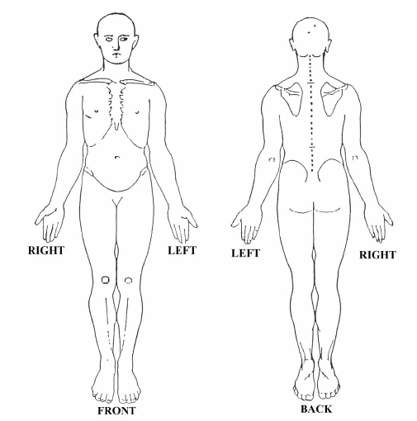

Patient Name

Signature Date

